

**North South University**

Department of Electrical & Computer Engineering

**EEE 111 / ETE 111 – Lab**

Electronics - 1

Faculty **:** Dr. Riasat Khan

Lab Instructor **:** Mehrab Hossain Likhon

**Lab Report**

Experiment No **:** 04

Experiment Name **:** Clipper and Clamper Circuits.

Date of Performance **:** 07-11-2021

Date of Submission **:** 14-11-2021

Section**:** Group No**:**

Group Member Info and Remarks**:**

|  |  |  |  |
| --- | --- | --- | --- |
| *Name* | *ID* | *Writer* | *Remarks* |
| 1. Md . Khalilur Rahman | 1811835042 | □ |  |
| 1. Md. Raqibur Rahman Roni | 1812935642 | □ |
| 1. Abdur Rahman Fahad | 1912024642 | □ |
| 1. Md. Saeem Hossain Shanto | 1912218642 | **✓** |

**Experiment Name:** Clipper and Clamper Circuits.

**Abstract:**

We studied the clipper and clamper circuits which gave us broad ideas about how they work and how they can modify the signals.

**Theory:**

**Clipper:** The diode clipper also known as voltage limiter is a wave shaping circuit that takes an input waveform and clips or cuts off some portion of its input. Clippers remove signal voltage above and below a specified level. Half wave rectifier can also be called as a clipper circuit. Because it clipped off the negative half cycle of the input signal.

**Types of Clipper circuits:**

Diode clipper circuits can be divided into 4 general types:

* Clipper circuit without bias – 1. Positive Clipper, 2. Negative Clipper
* Clipper circuit with bias – 1. Positive Clipper with bias, 2. Negative clipper with bias

There is also a combiner clipper circuit which has both positive and negative clipper together. A diode connected in series with the load can clipped off any half cycle of input depending on the orientation of the diode. 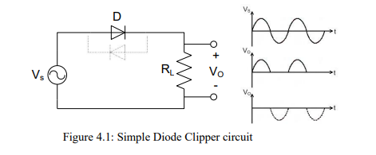

It is also possible to clip off a certain part of the input signal bellow a specified signal level by using a voltage source in reverse bias condition with the diode. If a battery of V volts is added to it, then for Vs above (V+0.7) volts the diode becomes forward bias and turns ON. The load receives above this voltage Level.

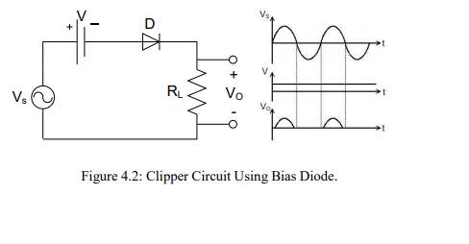

A diode connected in parallel with the load can clip off the input signal above 0.7 volts of one half cycle depending on the connection of the diode. Using two diodes in parallel in opposite direction both the half cycle can be limited to 0.7 volts.

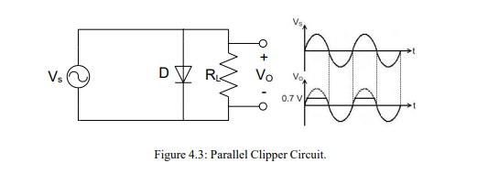

Using a biased Diode it is possible to limit the output voltage to a specified level depending on the attached battery voltage. Either the half cycles or both of them can be clipped off above a specified level.

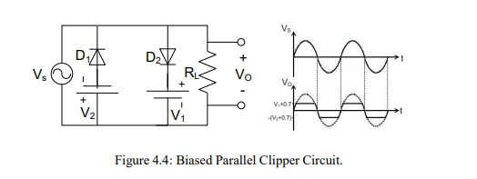

In practical case for both the series and parallel clippers voltage source is not added. Required voltage levels are maintained by adding more semiconductor diode.

**Applications of Clipper Circuit:**

* Used in FM transmitters to reduce noise
* To limit the voltage input to a device
* To modify an existing waveform to the desired output

**Clamper:** A Clamper is an electric circuit that changes the DC level of the DC level of a signal to the desired level without changing the shape of the applied signal. In other words, the clamper circuit moves the whole signal up or down. A DC clamper circuit adds a DC voltage to the input signal. For instance, if the incoming signal varies from -10 volts to +10 volts, a positive DC clamper will produce an output that ideally swing from 0 volts to 20 volts and a negative clamper would produce an output between 0 volts to -20 volts.

Types of Clamper Circuit:

* Diode clamper circuits can be divided into 4 general types:
  + Clamper circuit without bias – 1. Positive clamper, 2. Negative clamper
  + Clamper circuit with bias – 1. Positive clamper with bias, 2. Negative clamper with bias

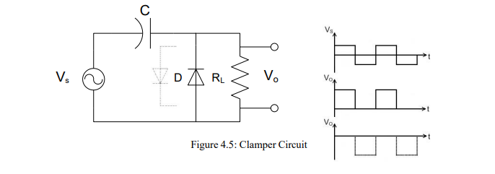

A Positive Clamper circuit is one that consists of a diode, a resistor and a capacitor and that shifts the output signal to the positive portion of the input signal. The figure below explains the construction of a positive clamper circuit.

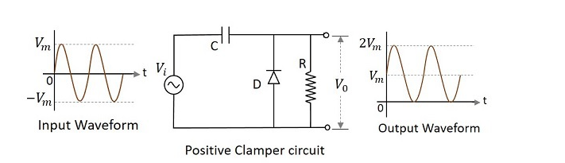

Initially when the input is given, the capacitor is not yet charged and the diode is reverse biased. The output is not considered at this point of time. During the negative half cycle, at the peak value, the capacitor gets charged with negative on one plate and positive on the other.

A Positive clamper circuit if biased with some positive reference voltage, that voltage will be added to the output to raise the clamped level. Using this, the circuit of the positive clamper with positive reference voltage is constructed as below. 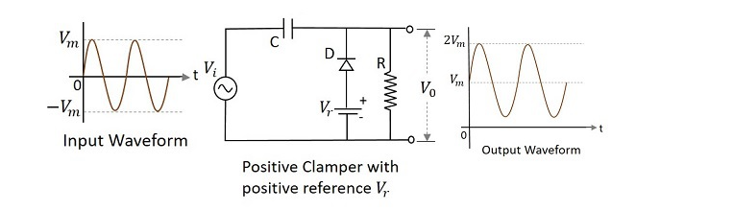

A Positive clamper circuit if biased with some negative reference voltage, that voltage will be added to the output to raise the clamped level. Using this, the circuit of the positive clamper with positive reference voltage is constructed as below.

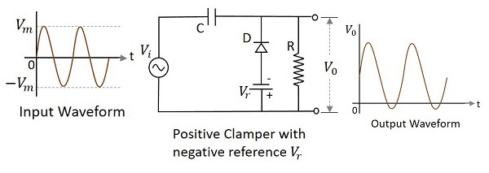

On the other hand, a Negative Clamper circuit is one that consists of a diode, a resistor and a capacitor and that shifts the output signal to the negative portion of the input signal. The figure below explains the construction of a negative clamper circuit.

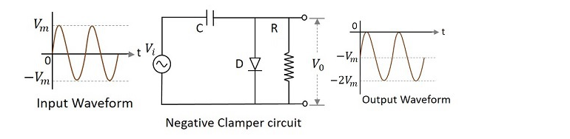

During the positive half cycle, the capacitor gets charged to its peak value vmvm. The diode is forward biased and conducts. During the negative half cycle, the diode gets reverse biased and gets open circuited.

A Negative clamper circuit if biased with some positive reference voltage, that voltage will be added to the output to raise the clamped level. Using this, the circuit of the negative clamper with positive reference voltage is constructed as below.

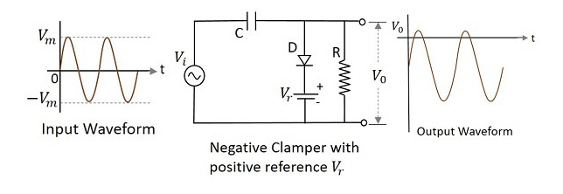

A Negative clamper circuit if biased with some negative reference voltage, that voltage will be added to the output to raise the clamped level. Using this, the circuit of the negative clamper with negative reference voltage is constructed as below.

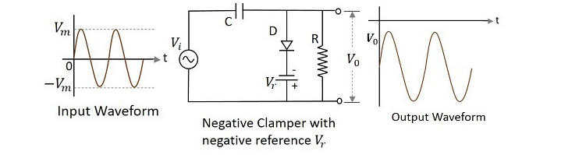

**Applications of Clamper Circuit:**

* Used as voltage doublers
* They find some applications in sonar and radar testing
* They are used to remove distortions in circuit
* Used in video processing equipment like TV

**Equipment List:**

|  |  |  |
| --- | --- | --- |
| Equipment Name | Value | Quantity |
| p-n junction diode | 1N4007 | 1 piece |
| Resistor | 100kΩ | 1 piece |
| Capacitor | 0.1uF | 1 piece |
| Signal |  | 1 piece |
| Trainer Board |  | 1 piece |
| DC Power Supply |  | 1 piece |
| Oscilloscope |  | 1 piece |
| Digital multi-meter |  | 1 piece |
| Chords and wire |  | As required |
| Function Generator |  | 1 piece |

**Circuit Diagram:**

**Series Clipper Circuit with bias:**

**1.**



**2.**



**Parallel Clipper Circuits with bias:**

**1.**

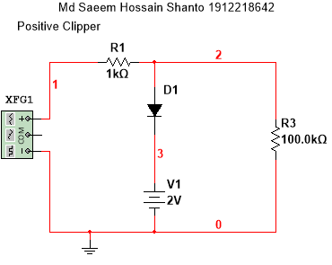

**2.**



**Data Table:**

Theoretical value: R = 1kΩ

Measured value: R = 1kΩ

Vs = 5 V(p-p).

|  |  |  |  |  |
| --- | --- | --- | --- | --- |
| **Vb**  **(V)** | **Vo (P-P)** | | | |
| **Negative Clipper** | | **Positive Clipper** | |
| **Vmin** | **Vmax** | **Vmin** | **Vmax** |
| **0** | **-692.6453 mV** | **4.9505V** | **-4.9235V** | **692.4143mV** |
| **2** | **-2.6762V** | **4.9100V** | **-4.9235V** | **2.6766 V** |
| **5** | **-3.6610V** | **4.9100V** | **-4.9505V** | **3.6619 V** |

**Graphs:**

Input voltage – 2.5 Vp

where Vmax = 4.9591V, Vmin = -4.9727V

**Negative Clipper with bias:**

**Bias voltage Vdc=0V**

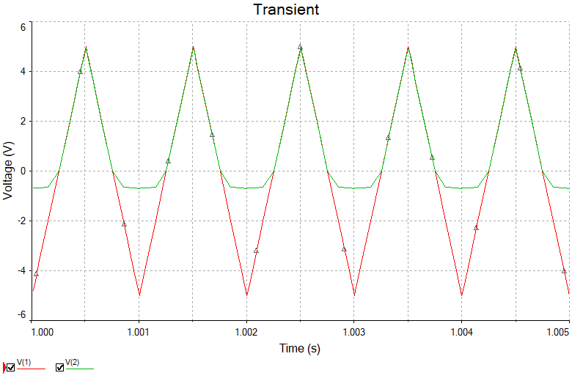

**Bias voltage Vdc=2V**

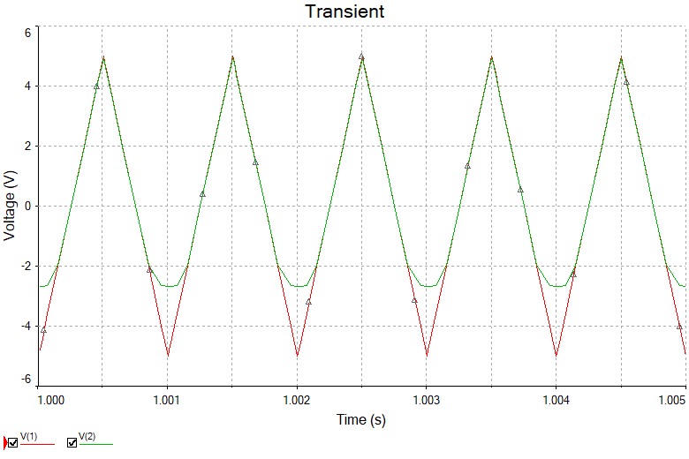

**Bias voltage Vdc=3V**

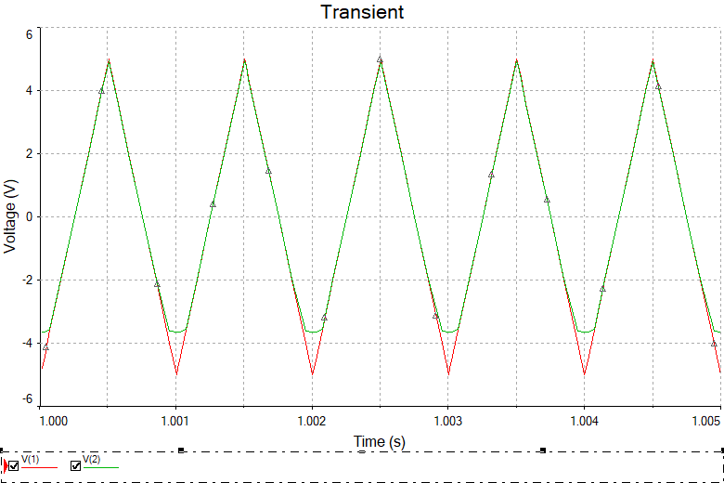

**Positive Clipper with bias:**

**Bias voltage Vdc=0V**

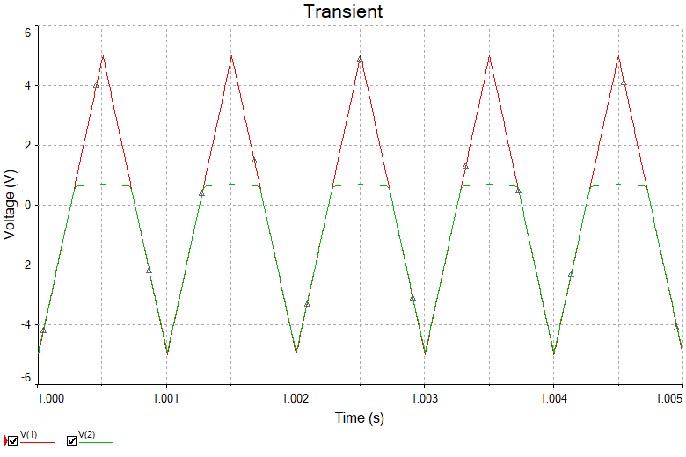

**Bias voltage Vdc=2V**

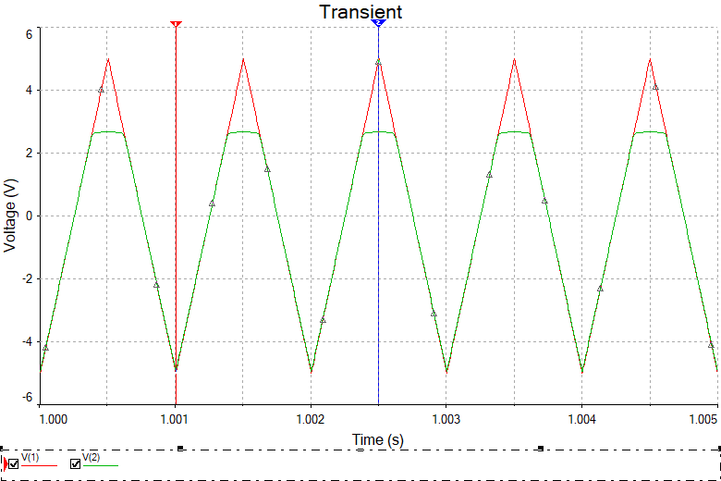

**Bias voltage Vdc=3V**

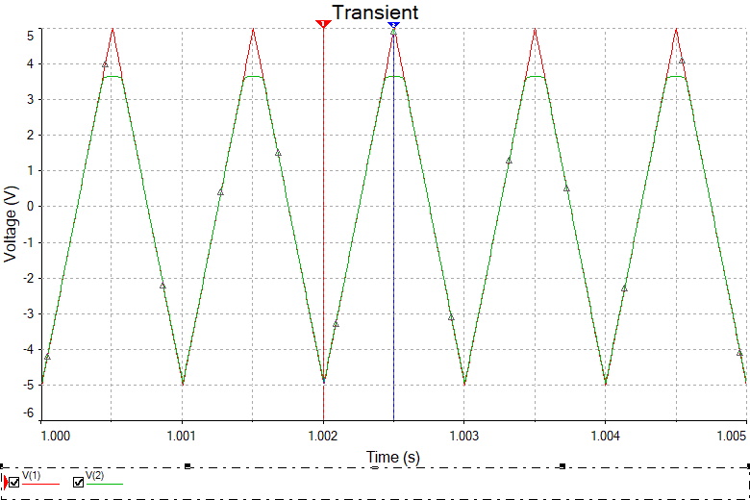

**Result Analysis:**

From Negative clippers’ graph, we can see that the negative clipper is cutting the negative signals of the output voltage. When the bias voltage was 0v , output Vmin was -692.6453 mV, and when bias voltage was 2V output Vmin was -2.6762V and when bias voltage was 3V, output voltage was -3.6610V . So we see that, the negative signal decreased as the bias voltage increased. But output Vmax had no effect due to the negative clipper.

On the other hand, from Positive clipper’s graph we see that the positive clipper is cutting the positive signals of the output voltage. When the bias voltage was 0v, output voltage Vmax was 692.4143mV, when bias voltage was 2V, output voltage Vmax was 2.6766 V and when bias voltage was 3V, output voltage Vmax was 3.6619 V. The output voltage positive signal increased as we increased the bias voltage of the clipper. But the output voltage Vmin had no effect by the positive clipper. It remained nearly constant all the time.

**Conclusion:**

Using the negative clipper we can control the negative voltage signal flow of the circuit and positive clipper can be used to limit the positive voltage signal without affecting the other signals. As we see the negative clipper had no effect on the positive signal but it limited the negative signal flow of the output voltage from the negative clipper’s output graph. The positive clipper does the same work with positive signal without effecting the negative signal. They does not distort the remaining part of the applied waveform.

**References:**

# 1. Electronic Devices and Circuit Theory, 11th Edition

**2.** **https://www.circuitstoday.com/diode-clippers**

3. <https://www.tutorialspoint.com/electronic_circuits/electronic_positive_clipper_circuits.html>